Change Expiration Date — Contingent Worker in SuccessFactors

Objective
Change the expiration date of a Contoso network account via SuccessFactors, preventing the automatic deactivation of the account.

Responsibility
This procedure is performed exclusively by the Contingent Worker's direct Manager. The IT analyst does not perform this operation — their role is to guide the manager when needed.

Step by Step
- The manager will receive the notification below with the user's details. Upon receiving the email, they should click the “SuccessFactors” hyperlink to go to the management tab.
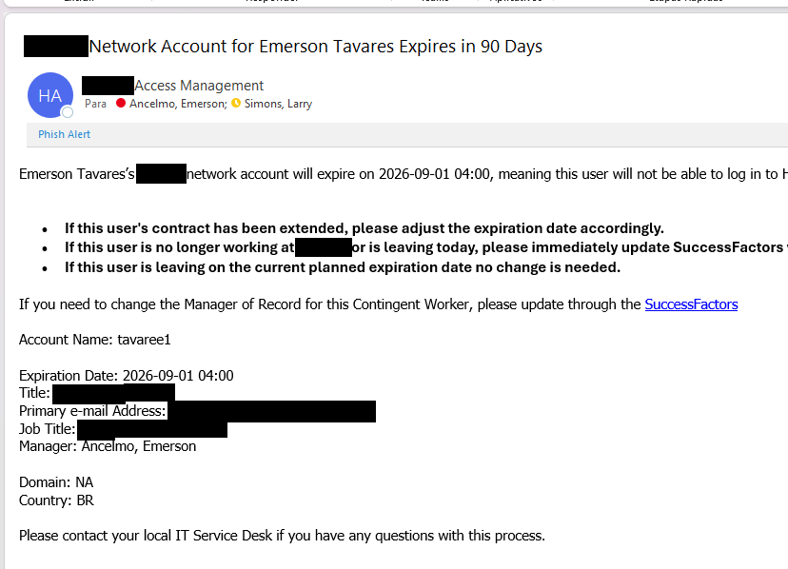

- With SuccessFactors open, click on “Manage My Team”.
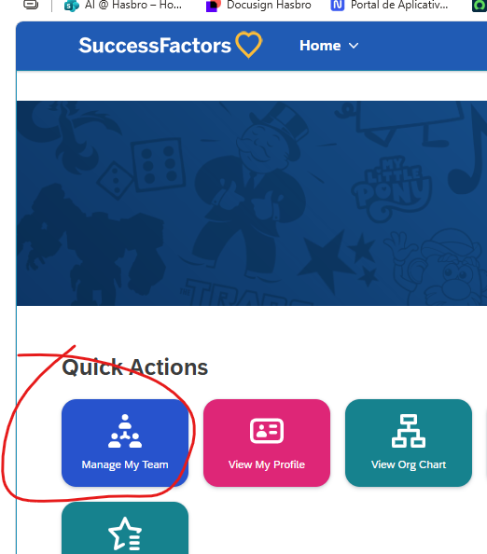
- In the following field, search the list for the user whose expiration date needs to be changed. Then click “Action”, then Other Actions, and click Edit Work Order Information.
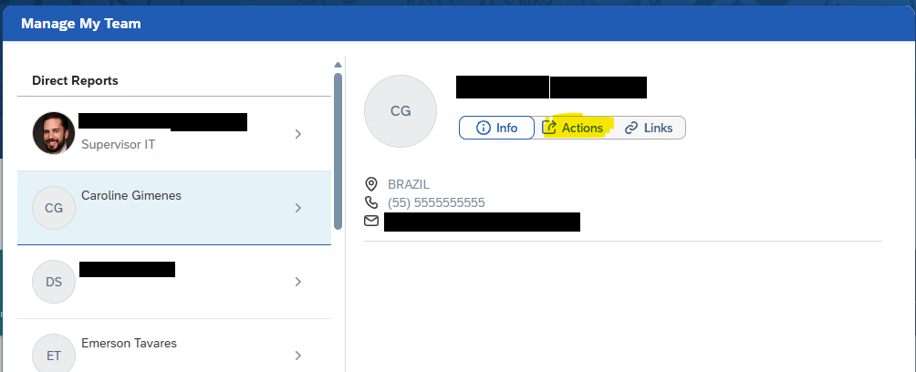

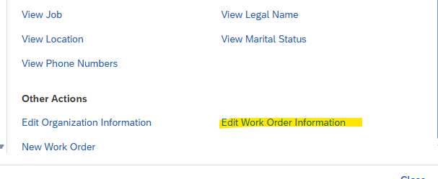
- In the End Date field, select or enter the new expiration date.

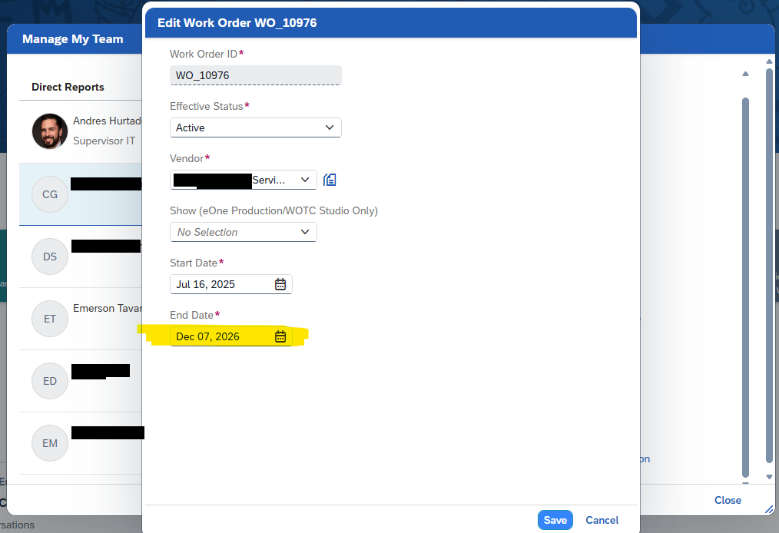
- Then click Save. Done. The account expiration extension has been completed. Allow up to 24 hours for synchronization with Active Directory and Contoso services.

NOTE: Although this procedure ensures an account remains active for longer, it can still be deactivated if the user does not log on to the network within a 30-day period, which will be characterized as inactivity.

Version History
Author | Version | Date | Description
Lucas Souza | 1.0 | Jun/2026 | Document creation

